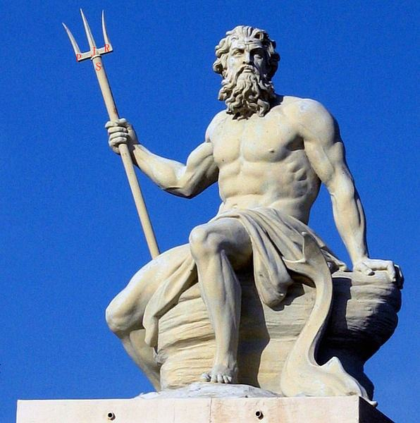

Poem of the Ocean
2021-12-01
Sailing in the ocean of big data.
In deep we code，
In truth they told.
As legend is memorized
Then we turn old.
It won't be cold,
As our hands hold.
Deep into the ocean,
Sailing free in soul.

